**Time series prediction using RNN – stock market analysis or weather forecasting**

**Introduction**

Time series prediction involves forecasting future values based on previously observed data points. This type of data is sequential and has temporal dependencies, making it ideal for problems like **stock market analysis** and **weather forecasting**. **Recurrent Neural Networks (RNNs)** are well-suited for time series prediction because they can learn from and retain information from previous inputs through their internal memory, which helps capture sequential dependencies in the data.

**Theory of Recurrent Neural Networks (RNNs)**

**RNNs** are a class of artificial neural networks designed to handle sequential data, where the output at a given time step depends not only on the current input but also on previous inputs. Unlike feedforward neural networks, RNNs have loops that allow information to persist, making them particularly useful for time-dependent tasks.

**How RNNs Work:**

1. **Memory**: RNNs have a hidden state that acts as memory, carrying information from one step to the next in a sequence. This allows the model to retain context and process data sequentially.
2. **Sequential Learning**: When processing time series data, RNNs use the hidden state to update predictions at each step based on both current and previous data points.
3. **Backpropagation Through Time (BPTT)**: This is the process used to train RNNs. The error is propagated back through each time step to adjust weights and minimize the prediction error.

**RNN Variants**: Due to limitations like vanishing gradients, **Long Short-Term Memory (LSTM)** networks and **Gated Recurrent Units (GRUs)** were developed. These are advanced types of RNNs that are better at capturing long-term dependencies in sequences by using gating mechanisms to control the flow of information.

**Prerequisites and Libraries**

The following tools and libraries are required to perform time series prediction:

* **Python 3.x**: The programming language used.
* **TensorFlow/Keras**: Deep learning libraries for building and training RNN models.
* **Numpy**: For numerical computations and handling array-based data.
* **Pandas**: For handling time series datasets.
* **Matplotlib/Seaborn**: For visualizing trends and forecasting results.

To install the necessary libraries:

pip install tensorflow keras numpy pandas matplotlib seaborn

**Overview of Time Series Prediction**

A time series is a sequence of data points indexed in time order. In stock market analysis, prices are recorded over time, while weather forecasting involves recording temperature, humidity, and other factors over time.

**Stock Market Analysis** involves predicting future stock prices based on historical data. The stock market is highly volatile, and accurate predictions are challenging but valuable for investors.

**Weather Forecasting** involves predicting future weather conditions based on patterns observed from historical data. The goal is to forecast temperature, humidity, or precipitation in future time steps.

**Recurrent Neural Networks (RNN) Overview**

RNNs are a class of neural networks designed to recognize patterns in sequences of data. Unlike traditional feed-forward networks, RNNs have loops that allow them to persist information across time steps, making them well-suited for time series prediction.

**RNN Architecture**

* **Recurrent Connections**: RNNs have a hidden state that carries information across time steps. This allows the model to remember previous inputs and make predictions based on sequential data.

**Long Short-Term Memory (LSTM)**

LSTMs are a special kind of RNN capable of learning long-term dependencies. They are more powerful than standard RNNs due to their ability to avoid the vanishing gradient problem through three gates: the input gate, forget gate, and output gate.

**Gated Recurrent Unit (GRU)**

GRU is another variation of RNNs that simplifies the LSTM architecture by combining the forget and input gates into a single update gate. GRUs are computationally efficient and often perform well for time series tasks.

**Steps for Time Series Prediction**

**Data Preprocessing**

Data preprocessing involves preparing the raw data for the RNN model by:

* **Normalizing Data**: Scaling data to a specific range (usually between 0 and 1) to improve model performance.
* **Sliding Window Technique**: Using a fixed-size window of past time steps to predict future values.
* **Handling Missing Values**: Filling or interpolating missing values in the time series to maintain continuity.

**Stock Market Analysis**

For stock market prediction, the dataset usually consists of historical stock prices (open, high, low, close) and trading volumes. The goal is to predict the closing price for the next day or future days based on past stock performance.

Key steps:

* Collect stock market data (e.g., from Yahoo Finance or Alpha Vantage).
* Choose a time window (e.g., using the past 60 days of data to predict the next day’s closing price).
* Train the RNN model on the training data and evaluate on the test set.
* Use LSTM/GRU layers to model the complex dependencies in stock prices.

**Diagram**

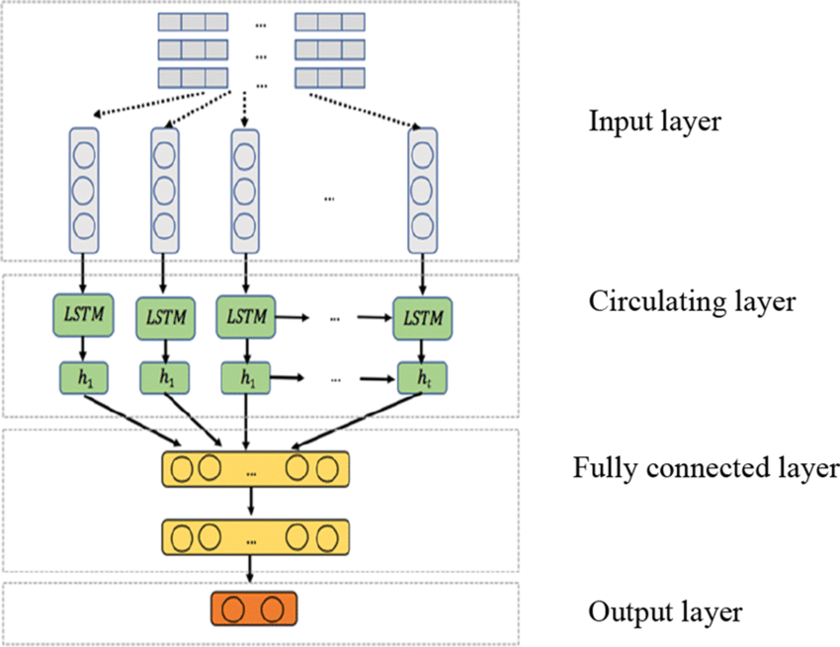

**Weather Forecasting**

In weather forecasting, the dataset contains temperature, humidity, wind speed, and other meteorological factors recorded over time. The objective is to predict future weather conditions based on past trends.

Key steps:

* Gather historical weather data (e.g., from meteorological stations or online weather datasets).
* Define a sliding window (e.g., using the past 7 days to predict the temperature of the next day).
* Build an RNN model that learns patterns from past weather data.
* The model can predict future temperature, humidity, and other factors.

**Model Training**

* Train the RNN model by feeding it time series data and minimizing a loss function (e.g., mean squared error).
* Backpropagation through time (BPTT) is used to adjust the weights of the RNN.
* The RNN learns to predict the next value in the time series based on the previous time steps.

**Model Evaluation**

After training, the model's performance is evaluated using various metrics:

* **Mean Squared Error (MSE)**: Measures the average squared difference between the predicted and actual values.
* **Mean Absolute Error (MAE)**: Measures the average absolute difference between predicted and actual values.
* **R² Score**: Determines how well the predicted values match the actual data.

The model is evaluated on a test dataset to determine its generalization capability.

**Advantages of RNNs for Time Series Prediction**

1. **Handling Sequential Data**:
   * RNNs are specifically designed to work with time series data, as they can maintain a memory of past data points and capture temporal relationships.
2. **Effective for Long-Term Dependencies** (with LSTMs/GRUs):
   * Advanced RNN variants like LSTM and GRU can effectively capture long-term dependencies, making them ideal for time series problems where past events can significantly impact future outcomes.
3. **Learning from Historical Data**:
   * RNNs can analyze past patterns and trends in data, which is useful for forecasting future values such as stock prices or weather conditions.
4. **Adaptability**:
   * RNNs can be used for a wide range of time series applications, from short-term to long-term forecasting, making them versatile across various domains.

**Disadvantages of RNNs**

1. **Vanishing Gradient Problem**:
   * Standard RNNs struggle with long sequences due to the vanishing gradient problem, where gradients become too small to effectively update weights during training. This limits their ability to capture long-term dependencies.
2. **Complex Training**:
   * Training RNNs, especially on long sequences, can be computationally expensive and slow. Models require more time and resources compared to feedforward networks.
3. **Limited to Sequential Data**:
   * RNNs are highly specialized for sequential data and may not be as effective for other types of data. Non-sequential data is better suited to traditional machine learning methods or feedforward neural networks.
4. **Overfitting**:
   * RNNs can easily overfit small datasets, especially when there are too many parameters relative to the data size. Regularization methods (e.g., dropout) need to be applied to prevent overfitting.

**Applications of RNNs in Time Series Prediction**

**1. Stock Market Analysis**

**Stock market analysis** involves predicting the future value of financial assets based on historical prices, volumes, and other market indicators. The stock market is highly volatile and depends on both short-term and long-term trends, making it a complex time series problem.

* **Why RNNs Are Useful**: RNNs (especially LSTMs) can learn from historical price movements and discover patterns over time. These patterns can help predict future prices or trends, although stock market data is inherently noisy and unpredictable.
* **Limitations**: Predicting stock prices is particularly challenging due to the market's dynamic nature. While RNNs can capture some trends, they may struggle to accurately predict sudden market movements or external influences (news, politics, etc.).

**2. Weather Forecasting**

**Weather forecasting** involves predicting future weather conditions (temperature, rainfall, wind speed, etc.) based on historical climate data. This is a typical time series problem because weather data follows patterns influenced by time and previous conditions.

* **Why RNNs Are Useful**: RNNs can learn from past weather data and forecast future conditions based on trends and seasonality. By capturing dependencies in temporal data, RNNs can generate accurate short-term and long-term weather predictions.
* **Limitations**: Long-term weather forecasting can be difficult due to the chaotic nature of atmospheric conditions. However, RNNs are useful for improving short-term forecasts and complementing traditional meteorological models.

**Results**

The RNN model generates predictions for both stock market analysis and weather forecasting. Results can be visualized using time series plots:

* **Stock Market Prediction**: A plot comparing actual stock prices with predicted prices over time.
* **Weather Forecasting**: A plot comparing actual and predicted temperatures, humidity levels, or other variables over time.

**9. Conclusion**

Recurrent Neural Networks (RNNs) are highly effective tools for time series prediction tasks like stock market analysis and weather forecasting. They excel in capturing temporal dependencies in sequential data and can be enhanced with architectures like LSTMs and GRUs to handle long-term dependencies. However, challenges like the vanishing gradient problem, computational complexity, and uncertainty in data remain significant hurdles. Despite these limitations, RNNs continue to be a valuable tool in financial markets, meteorology, and other fields that rely on accurate time series predictions.